# Meta-Link User Guide

## 1.0 Purpose

Meta-Link is a tool for connecting CyPhy with Creo to allow editing of Components or Designs both in Creo and CyPhy at the same time. The tool supports a bottom-up (Components created first, then from Components, Designs are assembled) workflow and enables Designs/Components to be viewed in Creo with limited editing capabilities.

## 2.0 Procedures

### 2.1 Installation

Meta-Link is installed together with the Meta Tool Chain. No additional installation steps are needed.

### 2.2 Workflow

The currently supported workflow is bottom-up. First, components need to be created (or, existing components can be used e.g. from VehicleForge). Then, a Design can be assembled from these Components. During the process it is expected that back and forth iterations are made in Creo and CyPhy at the same time. This document will go through the workflow steps and illustrates how Meta-Link supports each of these steps.

### 2.3 Terminology

Component – A component defined in CyPhy. It consists of a reference to one main Creo file (.prt/.asm) and additional information (mostly connectors and parameters)

Design – A Component Assembly defined in CyPhy (not to be mixed with a Creo assembly). A Design consists of references to Components and connections between these, plus additional meta-information like parameter values.

### 2.4 Accessing Meta-Link functionality

Meta-Link functionality can be accessed via the Meta-Link toolbar in Creo:

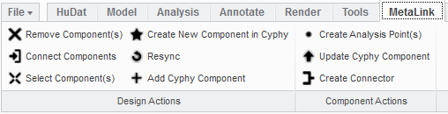

In CyPhy, it can be accessed via the Meta-Link toolbar button:



## 2.5 Workflow scenarios

### 2.5.1 Creating a Component from scratch

In the bottom-up approach, first components need to be available. These can be downloaded from VehicleForge and imported with the Component Importer, or can be created through Meta-Link in Creo.

1. From GME, start Meta-Link in “empty” mode with the button on the CyPhy toolbar:



2. Open a .prt/.asm file. This will be the main Creo resource of the component:

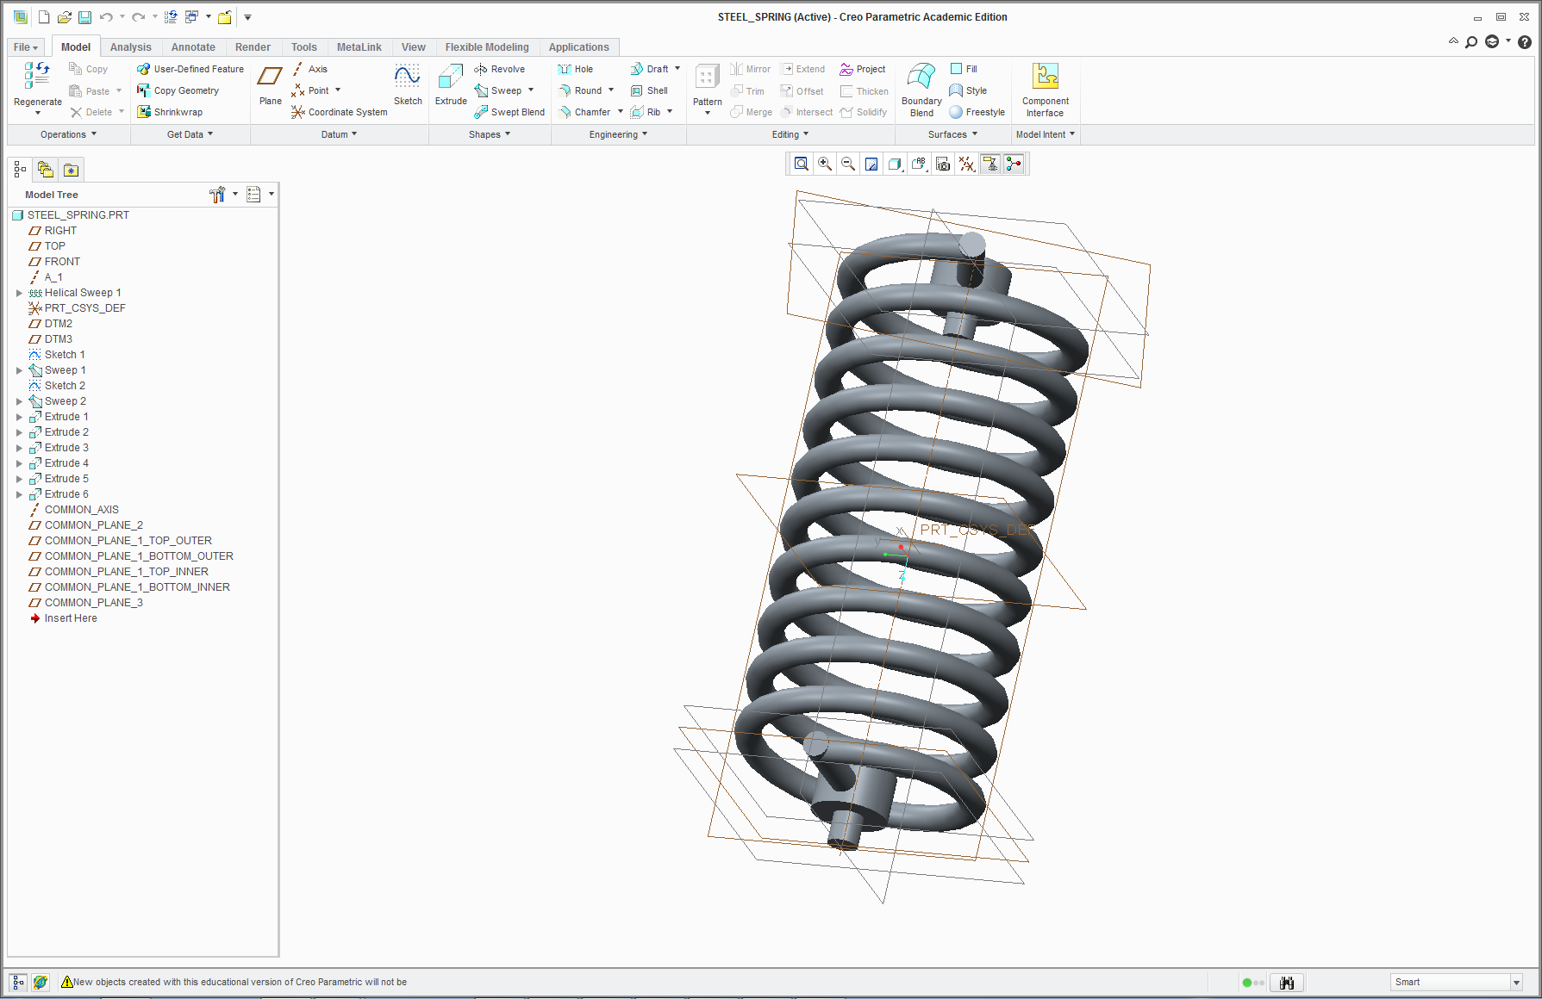

3. Select the model you’d like to have as the main resource for your component:

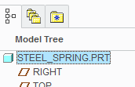

4. Select the *Create New Component* () function on the Meta-Link toolbar, and enter your new component’s name:

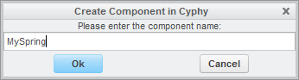

5. The new Component has been created in CyPhy:

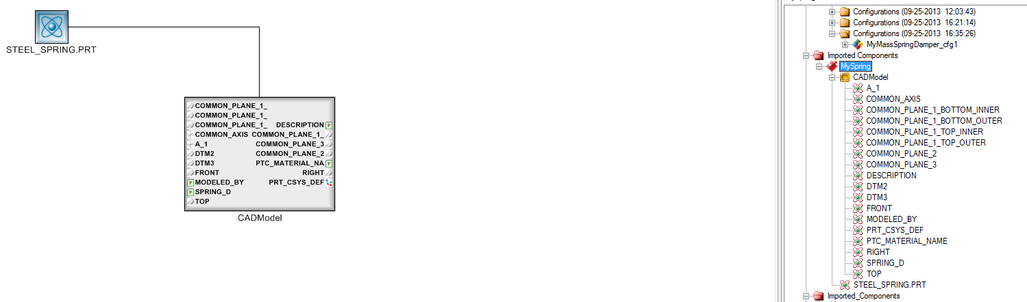

Note: all the resources (.prt/.asm) files used by the Component are going to be copied into a newly created directory under the *components* folder in your model’s directory (the component directory).

Note: after creating the new component, Meta-Link switches to Component editing mode on the newly created component. So the component doesn’t have to be re-opened in Creo.

### 2.5.2 Adding connectors to the newly created Component

To be able to use the newly created Component in Designs, connectors must be added to it which would allow specifying connections between Components. Connectors can be created in CyPhy or Creo. The description of how to create connectors in Creo is:

1. Open the component in Meta-Link by selecting the Meta-Link button on the CyPhy toolbar (select “*Open existing component*”):

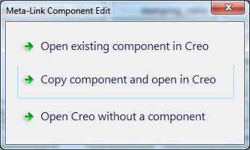

1. Select the datums in Creo which would form the connector:

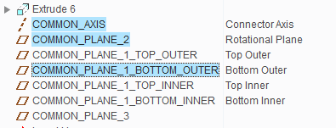

Note: The names in the right column show the corresponding datum names in CyPhy. You can rename your datums to a more convenient name after you’ve created the component.

1. Use the *Create Connector* button () and enter the name of the connector. Below the 3 created connectors in CyPhy (*Inside Hole*, *Outside Pin*, *Inside Pin*)

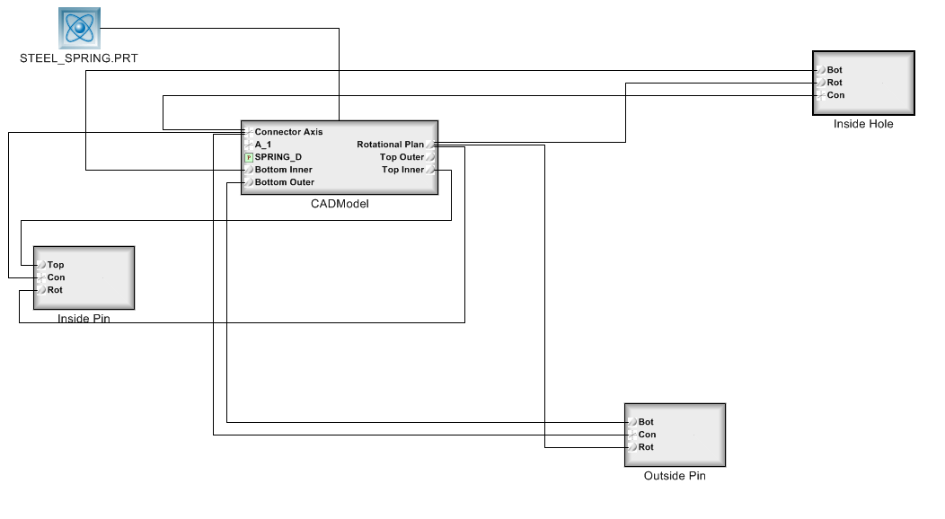

### 2.5.3 Assembling a Design from Components

Once your components are ready, you can start assembling your Design:

1. Create a new design in CyPhy (of course you can open an existing one), and select it into the GME editing area by double-clicking it.
2. Press the Meta-Link toolbar button in CyPhy, which will start up Creo and you’ll see an empty Creo assembly. Note: Meta-Link will always open what’s visible in your editing area. If nothing is visible, it opens in *Empty Mode*.
3. Start adding components in Creo by using the *Add CyPhy Component* () button on the Meta-Link toolbar. In the popup window select the component you’d like to add:

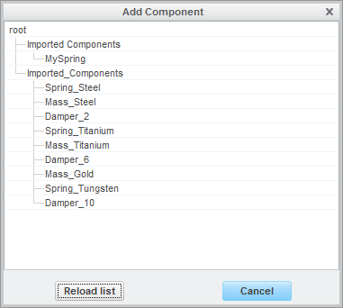

1. After closing the window please see that both in CyPhy and Creo your component has been added.
2. Continue adding components to your model. Note: at this point components are unconstrained so they’re just put in the middle of the coordinate space.

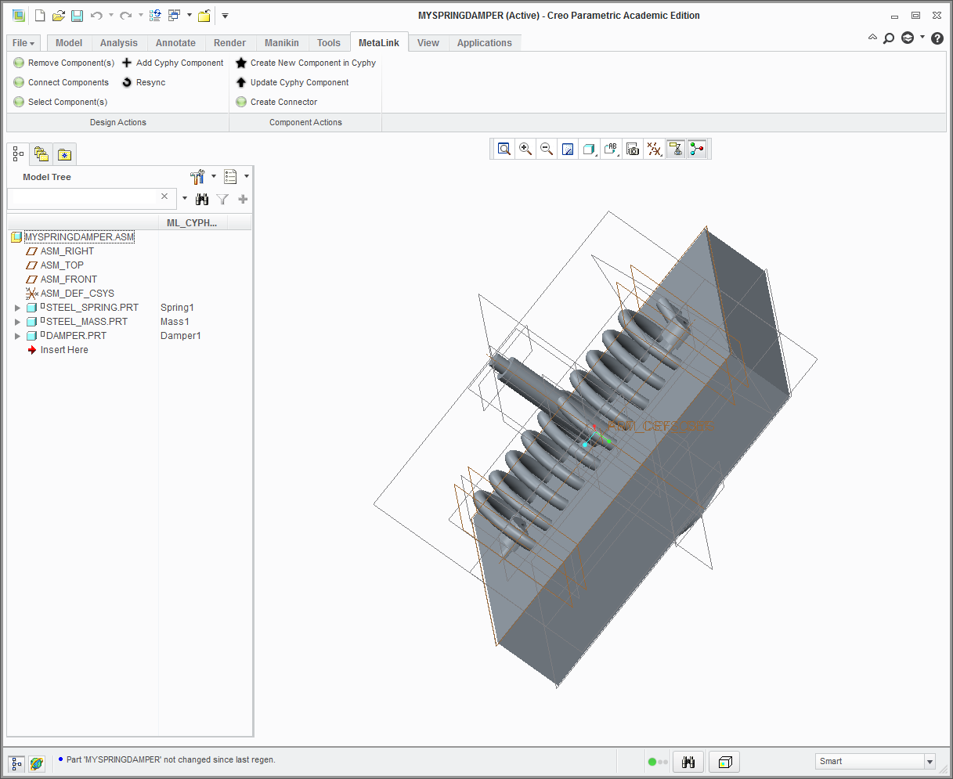

### 2.5.4 Connecting Components in the Design

To put Components into place, connections must be added to the Design. Connections are allowed between connectors defined within Components. Connections can be created in both CyPhy and Creo.

1. To create a connection in CyPhy, simply connect two connectors. (Please see the GME manual)
2. To create a connection in Creo, press select the 2 Components you’d like to connect and press the *Connect Components* () button. Note: you need to select exactly 2 components here.
3. In the dialog below, select the 2 connector you’d like to use for connection:

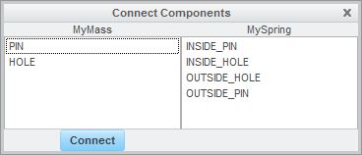

1. After pressing connect, the parts should appear as connected in Creo (and CyPhy):

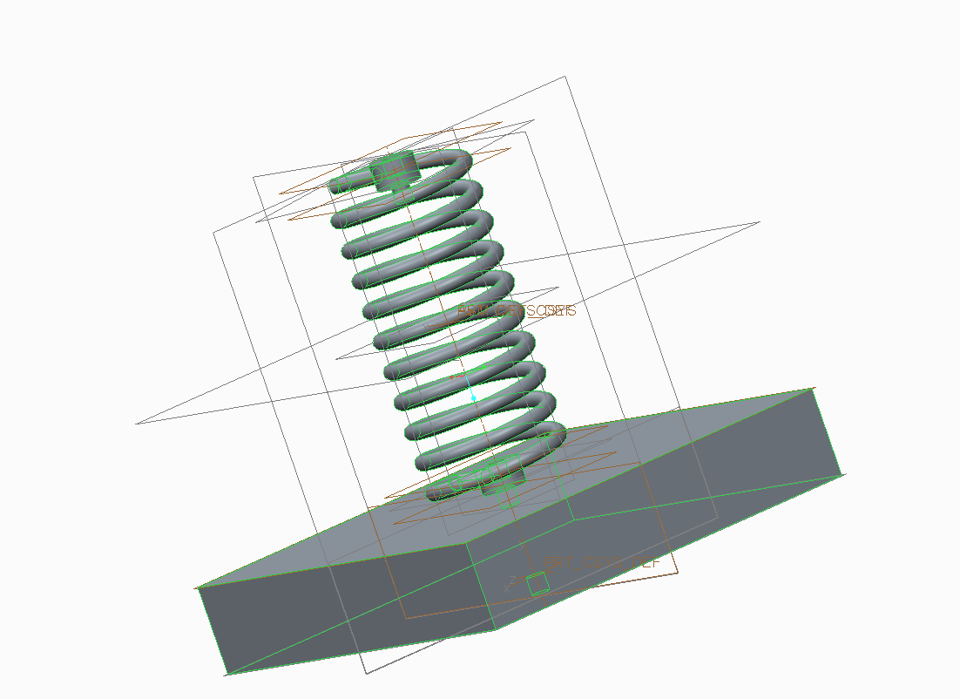

### 2.5.5 Removing components from a Design

After selecting components in Creo, they can be removed from the Design by using the *Remove Component(s)* button. Note: Simply deleting a component in Creo will not remove it from the Design. It is a design decision that the deletion should be explicit.

## 2.6 Modes

#### 2.6.1 Empty mode

In case no Component or Assembly open in the CyPhy editor view, Creo will start up in an empty mode (No Component will be opened). In this mode the user can create a new component from scratch.

#### 2.6.2 Component editing mode

If a Component is open in CyPhy, the user can select between three options:

1. Open the selected Component in Creo
2. Create a copy of the Component with a new AVM Id and open it in Creo
3. Open Creo in Empty mode.



Figure - Selection dialog in Component Editing mode

#### 2.6.3 Design editing mode

If a Design is open in CyPhy, the user has to select the directory where the auxiliary Creo files are located for the Design. If no directory is selected, only components in the project manifest will be used. After selection and pressing ‘Ok’, Creo starts up with the Design being opened.

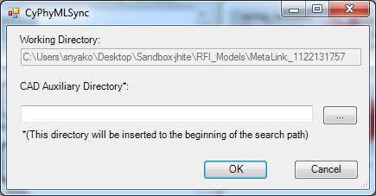

Figure - Selection dialog in Design Editing mode

In design or component editing mode, the open entity is marked with **bold** in the CyPhy Browser Tree:

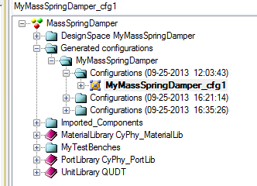

Figure - CyPhy Browser Tree showing the component under edit

## 2.7 Re-syncing Creo content

At any time during editing either a Design or Component, you can re-generate the content of Creo from CyPhy with the *Re-sync* () button. Note: this will overwrite the changes made in Creo and replaces the current Creo content with whatever exists in CyPhy.

## 2.8 Modifying Design parameters

Whenever a Design is open via Meta-Link in CyPhy and Creo, changes to parameters in CyPhy are reflected in Creo immediately.

Example:

1. Open a Design in CyPhy
2. Start Meta-Link
3. Modify a Design parameter: 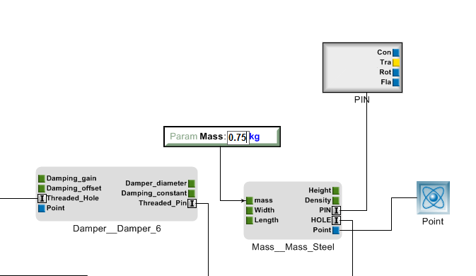

Figure - Modifying a parameter in a Design

1. The change should be reflected in Creo

## 2.9 Update Component from Creo to CyPhy (Creo Update)

Pressing the *Update CyPhy Component* () button will update the CyPhy component. In Component editing mode, the currently edited component is going to be updated. In Design editing mode, the selected component is going to be updated.

Example:

1. Open a Component/Design in CyPhy
2. Start Meta-Link
3. Add a datum/modify parameters in Creo
4. In design editing mode: select component from tree
5. Press the update button

Changes should be reflected in your CyPhy view.

Note: The update operation will bring your CAD resources to the current status. This means all the cad files are copied to the “CAD\” folder within the component directory (if they are at a different location) and the CyPhy model is refreshed with the new files (resource references are added and removed as needed). If there’s a new manufacturing resource created (a manufacturing resource is any file in the “Manufacturing\” folder), it’ll be added to the model. Although, existing manufacturing resources are not going to be removed.

## 2.10 Editing multiple components at the same time

There’s only one Design can be edited at once with Meta-Link. However, it is possible to edit multiple components at the same time. If a Component is changed, the Design can be re-synced to reflect the changes.

## 2.11 Using HuDat with Meta-Link

The recommended workflow for HuDat and Meta-Link is the following:

1. Open the component to be worked on
2. Use the HuDat tool to generate the hull (new .prt/.asm and manufacturing files are generated)
3. Use the “Creo Update” feature to update the component in CyPhy. The new Creo model files are getting added to the CyPhy model in this step as resources, along with the newly created manufacturing resources.

## 2.12 Release Notes

## 2.13 Future Tool Capabilities

Future Tool capabilities and enhancements include the following:

* Handling component hierarchies
* Set up bolted/welded connections

## 3.0 Configuration

Meta-Link looks for the “metalink.config” json file in the user’s My Documents directory. The supported options are:

* "ConfigProFile": "<filename>" – reads the content of <filename> and concatenates it to the generated config.pro file